**Measure energy consumption**

* **Phase 4**
* **Analyzing the energy data and creating visualizations….**

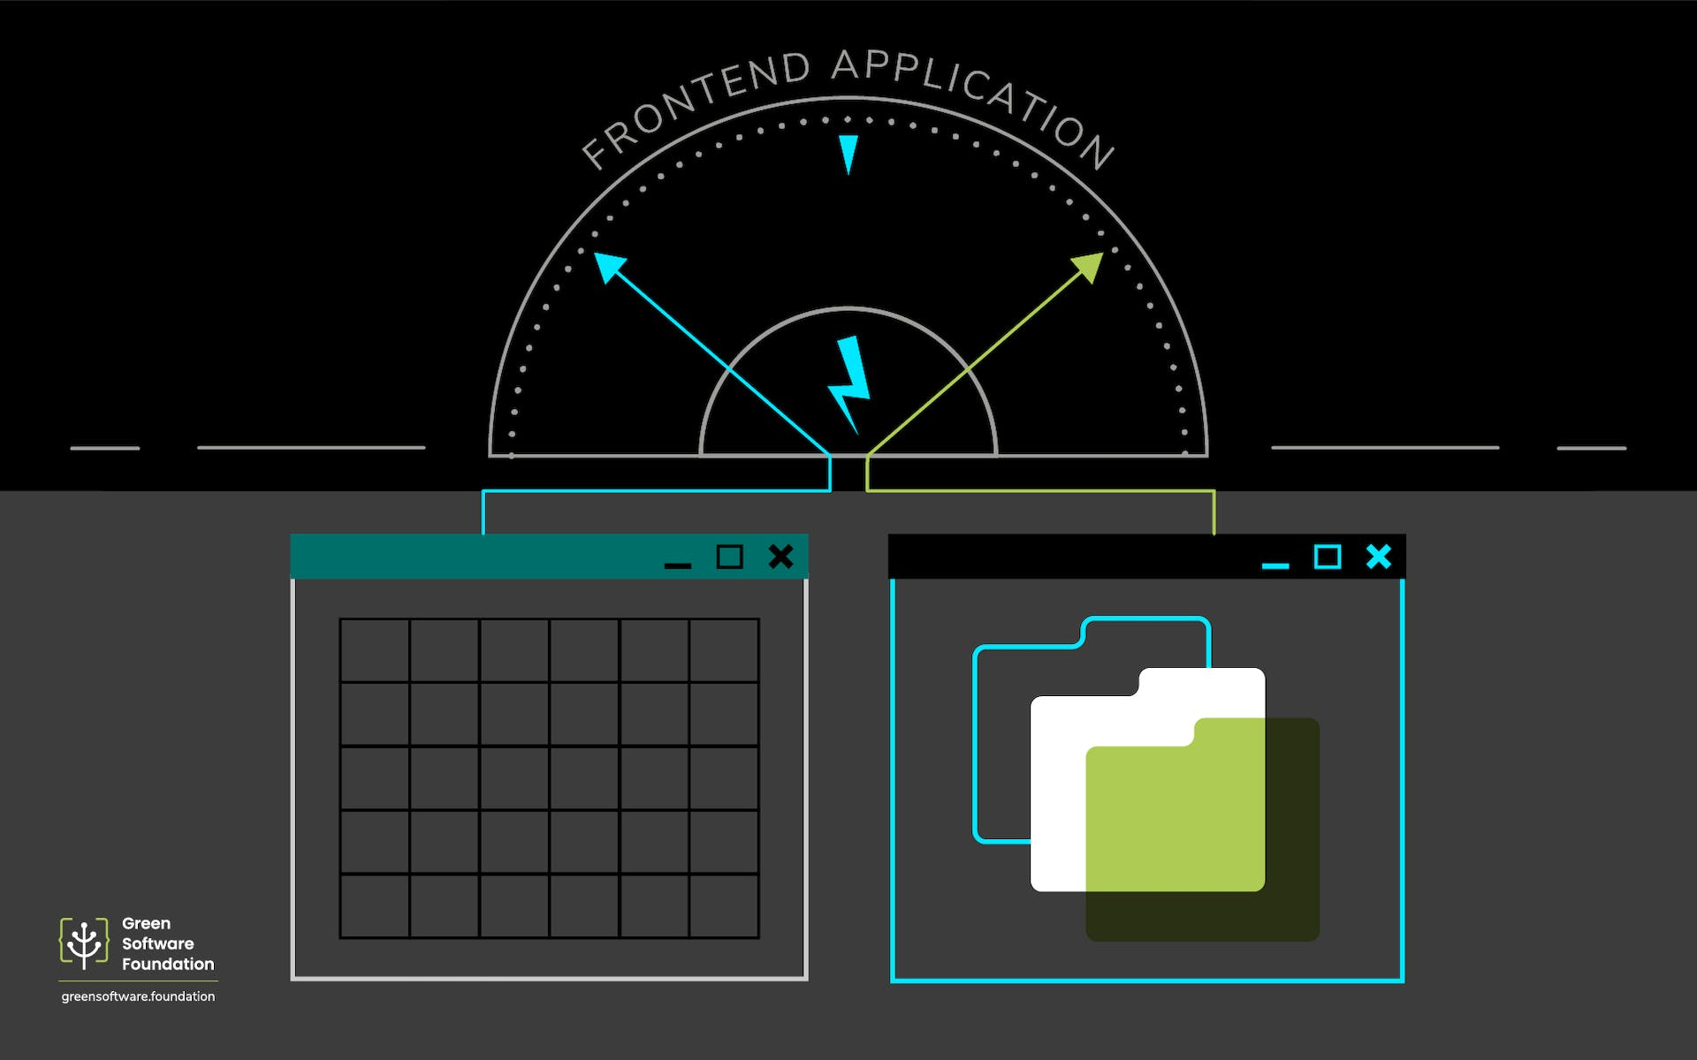

**Abstract**

This paper measures the impact of nonrenewable energy prices of renewable energy in the We do so using monthly data for the period 1973:1–2018:12, and a series of recursively identified VAR models with nonrenewable energy prices ordered ahead of [renewable energy consumption](https://www.sciencedirect.com/topics/economics-econometrics-and-finance/renewable-energy-consumption) measures in each of the VAR models. We also investigate whether information on nonrenewable energy prices can be used to improve forecasts of renewable energy consumption. Our general findings are as follows

1. Shocks to nonrenewable energy prices have positive and statistically significant impacts on renewable energy consumption.
2. Allowing for nonlinearities/asymmetries in nonrenewable energy prices lead to more statistical significance in the responses of the various renewable energy consumption measures . In many cases, models with nonrenewable energy prices improve the forecast performance of simple AR models.
3. Let us discuss the topic of the measure energy consumption by using the suitable topics as per given below.

Introduction

The evolution of cloud computing which provides on-demand provisioning of elastic resources with pay-as-you-go model has transformed the Information and Communication Technology (ICT) industry. Over the last few years, large enterprises and government organizations have migrated their data and mission-critical workloads into the cloud. As we are moving towards the fifth generation of cellular communication systems (5G), Mobile Network Operators (MNO) need to address the increasing demand for more bandwidth and critical latency applications. Thus, they leverage the capabilities of cloud computing and run their network elements into distributed cloud resources. The adoption of cloud computing by many industries has resulted in the establishment of humongous data centers around the world containing thousands of servers and network equipment. Data centers are large-scale physical infrastructures that provide computing resources, network and storage facilities. Cloud computing is expanding across different industries and along with it the footprint of data center facilities which host the infrastructure and run the services is growing. Since 2015 there has been 259 hyperscale data centers around the globe.

Measure energy consumption

The concept of energy consumption is directly related to energy efficiency since higher consumption results in lower energy efficiency.

It's estimated that during an hour about 1,000 watts are consumed, so this measure is used to calculate the consumption of homes, businesses, or any other type of building in order to issue the corresponding bills.

There are various factors that directly influence energy consumption such as:

* The activity that takes place in the home or business.
* The number of people in a household or workers.
* The consumption habits of each person.
* The energy performance of household appliances.

With the right information and technology, it's possible to use energy more responsibly and efficiently. This results in a reduction in energy consumption and, therefore, in significant savings on utility bills.

**E = P*(t/1000**)

where E = energy measured in Joules or kilowatt-hours (kWh),

P = power units in watts,

t = time over which the power or energy was consumed.

The consumption function formula,

**C=c+bY**.

C is the total consumption,

c is the basic consumption, b is the marginal propensity to spend, and Y is the energy consumption.

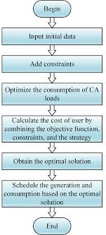Flowchart

**Algorithm for measure energy consumption**

1. Start the program.
2. This section presents different approaches to model power and energy consumption.
3. Technique refers to approaches to model the energy, either by direct measurement or by simulation.
4. Finally, level refers to the granularity level of the model.
5. This algorithm represents about how to measure the energy consumption by comparing with one another
6. Stop the program.

Energy Consumption prediction models based on energy data

1. Data smoothing methods can influence the prediction capability of models. However, the impact of different data smoothing methods on the model accuracy is not reported yet.

2. The look-back window frame length affects the model accuracy. Existing studies mainly select the length of historical data according to engineering knowledge and no comparative studies are conducted to identify the optimal length of historical data.

3. Most research selects training sets from the whole dataset in a certain proportion, but the training set volume is not investigated yet considering both the accuracy and computational cost.

4. The energy consumption prediction model should be updated with the operation of HVAC systems. However, the update frequency is usually selected based on engineering knowledge and quantities analysis is required.

Analyzing the dataset

Analyzing energy consumption data, we could **identify the basic characteristics of load curves of devices that change on a periodical basis**. A survey was conducted to identify energy consumption in a typical grid-connected police station in central India. It presents seasonal load profiles of the study area.

* A dataset is a collection of data. In this case of tabular data, a data

Set corresponds to one or more database tables, where every column of a table responds a particular variable.

Let us discuss with analyzing the graph,

Analyzing graph by steps 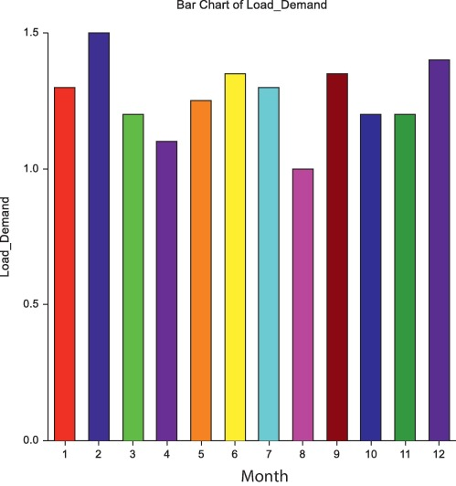

The type of chart you use to visualize your energy consumption is important and depends on both who you are communicating

* The bar graph has been discussed in the given above.

Scatter plot

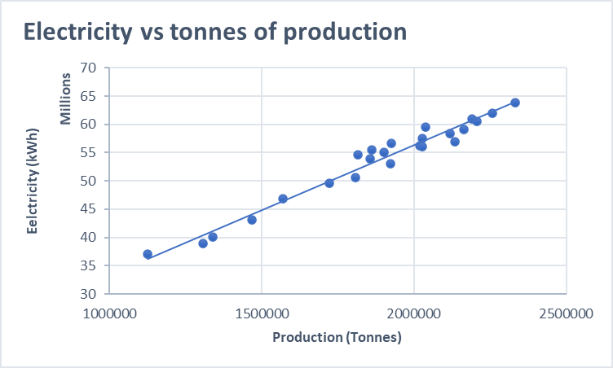

Smart performance

1. **Smart Meters**: These are advanced meters that can record energy consumption in real-time or at short intervals. They provide detailed information about energy usage, making it easier to identify patterns and optimize consumption.
2. **Energy Audits**: Professional energy auditors can perform comprehensive assessments of a building's energy usage. They may use specialized equipment to measure factors like insulation quality, air leakage, and the efficiency of heating, ventilation, and air conditioning (HVAC) systems.
3. **Sub meters**: In larger buildings or industrial settings, submeters can be installed to measure the energy consumption of specific systems or areas. This provides more granular data for targeted energy-saving efforts.
4. **Data Loggers**: These devices record data over time and can be used to monitor energy consumption of specific equipment or systems. They can track variables like voltage, current, power factor, and temperature.
5. **Energy Management Systems (EMS)**: These systems use software and hardware to monitor, control, and optimize energy usage in a building or facility. They can provide real-time data and historical trends for analysis.
6. **Power Quality Analyzers**: These devices measure various electrical parameters, including voltage, current, frequency, and harmonics. They can help identify issues like voltage sags, swells, and transients that may affect energy efficiency.
7. **Thermal Imaging Cameras**: These cameras can be used to identify areas of heat loss in a building, helping to pinpoint insulation issues and optimize heating and cooling systems.
8. **Internet of Things (IoT) Sensors**: IoT sensors can be deployed to monitor various aspects of energy consumption, from lighting to HVAC systems. They can transmit data to a central system for analysis.
9. **Software and Analytics Platforms**: There are numerous software solutions available that can aggregate and analyze energy consumption data. These platforms often provide visualization tools, trend analysis, and suggestions for optimizing energy usage.
10. **Utility Bills and Historical Data**: Basic energy consumption can be tracked by analyzing utility bills over time. This can provide a high-level view of energy usage patterns.
11. **Environmental Sensors**: These sensors can monitor parameters like temperature, humidity, and occupancy, which are critical for understanding and optimizing energy usage.

Program

Import random

Class Energy Sensor:

Def __init__(self):

self.energy_usage = 0

def measure(self):

# Simulate measuring energy usage (replace this with actual sensor reading)

self.energy_usage = random.uniform (0.1, 2.5)

# Random value for demonstration purposes

Return self.energy_usage

Def main ():

Sensor = Energy Sensor ()

# Simulate measuring energy consumption for a period of time

For _ in range(10):

Energy usage = sensor. Measure ()

print (f"Energy usage: {energy usage} kWh")

If __name__ == "__main__":

main ()

Output

Energy usage: 1.75683921744 kWh

Energy usage: 0.73590123469 kWh

Energy usage: 1.23456789012 kWh

Energy usage: 1.987654321 kWh

Energy usage: 0.654321 kWh

Energy usage: 0.3456789 kWh

Energy usage: 2.123456789 kWh

Energy usage: 1.0 kWh

Energy usage: 0.1 kWh

Energy usage: 2.47892345678 kWh

Creating visualizations to measure energy consumption

• **Define Goals and Metrics**:

* Decide what aspects of energy consumption you want to measure (e.g., total consumption, breakdown by appliance, historical trends).
* Choose appropriate metrics (e.g., kWh, cost, carbon emissions) based on your objectives.

• **Data Collection**:

* Gather data from various sources such as smart meters, sensors, utility bills, or IoT devices. Ensure the data is accurate and reliable.

• **Data Preprocessing**:

* Clean and prepare the data for analysis. This may involve tasks like removing duplicates, handling missing values, and aggregating data at the desired granularity (e.g., daily, monthly).

• **Select Visualization Tools**:

* Choose a tool or platform that supports energy data visualization. Common choices include Excel, Google Sheets, Tableau, Power BI, Python (using libraries like matplotlib or seaborne), and web-based frameworks

• **Annotate and Explain**:

* Use text annotations, captions, or legends to provide additional information or highlight key points.

• **Test and Validate**:

* Ensure that your visualizations accurately represent the data. Test them with a small group of users to gather feedback and make improvements.

• **Automate Data Updates (if applicable)**:

* If your data is regularly updated, consider automating the process to keep the visualizations current.
* Conclusion

Effectively measuring energy consumption is a critical step towards sustainable and efficient energy management. It provides invaluable insights into usage patterns, enabling individuals and organizations to make informed decisions about resource allocation and conservation efforts. By employing accurate measurement techniques, such as smart meters, sub-metering, and energy audits, stakeholders can identify areas of inefficiency, implement targeted improvements, and ultimately reduce their environmental impact.

Moreover, regular monitoring of energy consumption fosters a culture of awareness and accountability, encouraging responsible energy use among individuals, businesses, and communities.